Generating a Meet Entries file
Admin Level - Email/Print/Calendar
- Go to your Events page.
  - Chameleon users: Click your Events tab in the top menu or more... on the home page Events section.
  - New CMS users: In the side menu click Events & Competition > Team Events.
- Click your desired event’s Edit Commitment button.
- Click the Committed Athletes tab.
- Click Generate Entry Files button. Important: Only the APPROVED individual entries and RELAY entries will be processed.
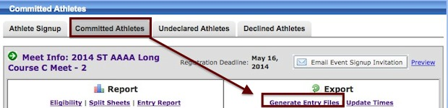
- From the File Generation Screen, Step 1 generates the SD3 file to send to the meet host. Click either Save Standard SD3 File or Save Extended SD3 File.
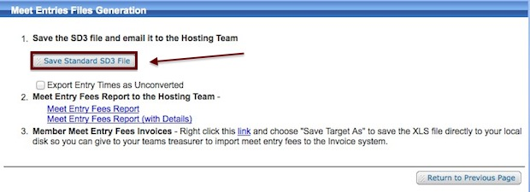
- After saving the SD3 File, attach it to an email and send it to the meet host.
The Extended SD3 file includes event sub-letters (5a, 5b, 5c) which are used primarily by summer teams. The Standard SD3 does not contain these extra designators. USA Swimming teams will need to use the Standard SD3. The Extended button will only present itself if your meet events file contains these letter designators.

